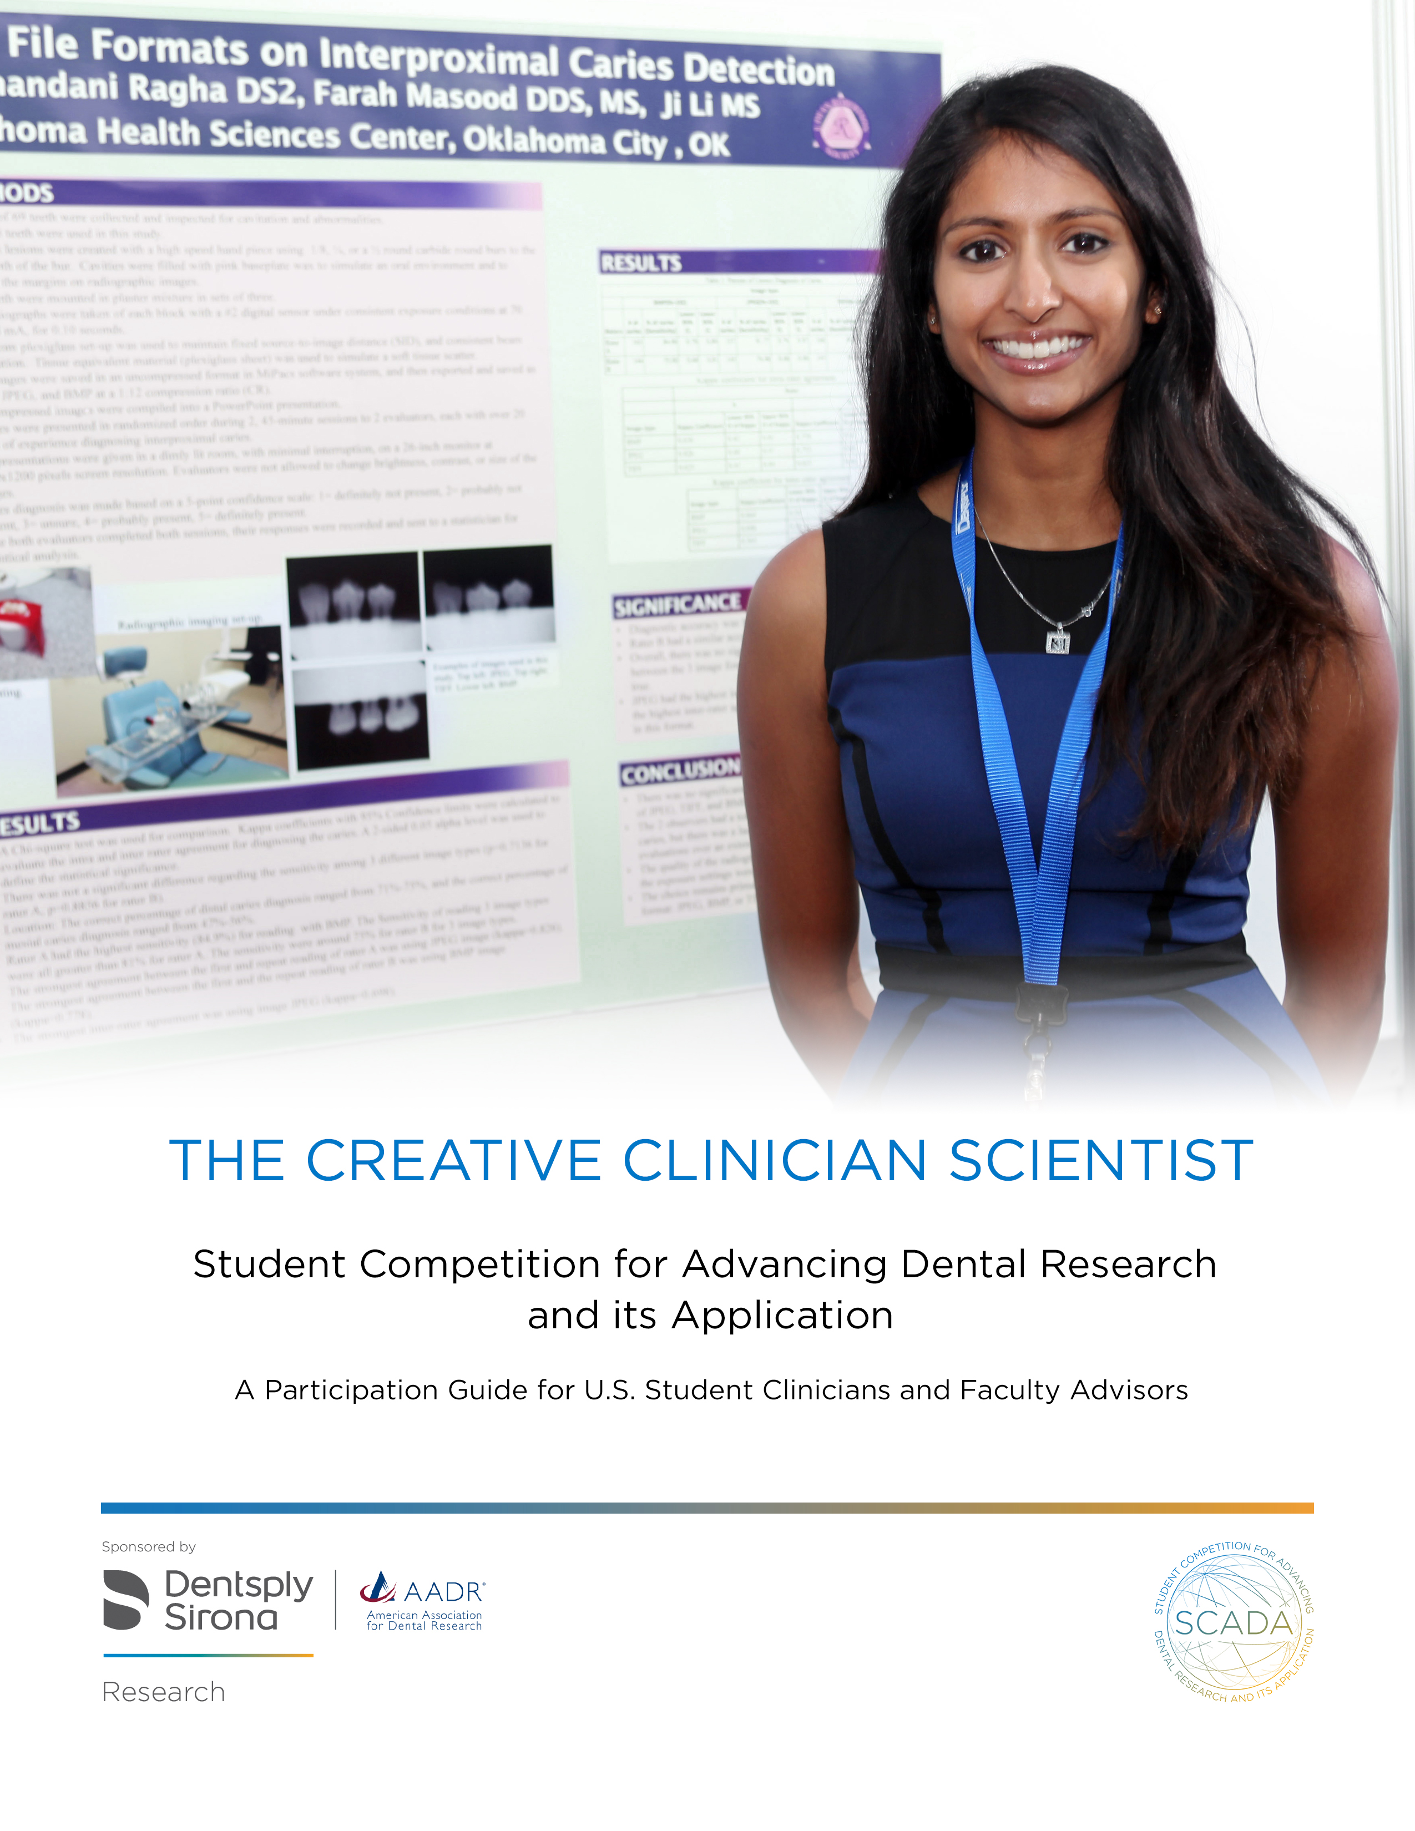

 | Table of Contents
 |  | Page
Introduction |  | 1
Program Requirements |  | 1
Student Eligibility |  | 2
Co-Student Clinician Policy |  | 4
Competition Rules |  | 5
Student Clinician Benefits |  | 8
Sample Candidate Rating Form |  | 10

American Association for Dental Research / Dentsply Sirona Student Competition for Advancing Dental Research and its Application (SCADA)

Dentsply Sirona’s vision is to deliver innovative dental solutions to improve oral health worldwide. This vision cannot be achieved without a strong commitment to scientific discovery. One way we encourage innovative thinking is through our long-standing support of student research.

The first International Association of Student Clinicians - American Dental Association (ADA) or SCADA Program was launched as a joint venture between DENTSPLY International and the American Dental Association in 1959 during the centennial session of the ADA in New York City. The program was conceived by the late Dr. Harold H. Hillenbrand, former Executive Director of the ADA, and the late Mr. Henry M. Thornton, former Chairman of DENTSPLY International. Their goal was to establish a program that would stimulate student interest in dental research and introduce dental students to the American Dental Association.

SCADA’s mission today remains the same -- to advance the art and science of dentistry by introducing pre-doctoral students to the world of dental research. By immersing themselves in research, students learn how to apply the scientific method to best serve clinical problems, as well as broaden their understanding of career opportunities in dentistry. In fact, many of today's dental educators were first drawn to research and academic careers through SCADA. With its 55+ year history, the program has seen dental students across the globe become leaders in the profession.

What is SCADA?
SCADA – the Student Competition for Advancing Dental Research and its Application – is a global student competition, aimed at engaging the next generation of dental professionals in the discovery and advancement of dental research, and the improvement of oral health worldwide.

The competition was founded in 1959 with the aim to help students discover research, advance themselves, and find inspiring ways to improve dental care – and continues in this spirit today.

Program Goals

Engage students to Discover the importance and power of dental research.

Provide opportunities for students to Advance their Research skills and careers.

Inspire students to look for new ways to have a positive impact on dental care and oral health.

Program Requirements
The scientific program of the Annual Session of the American Association for Dental Research (AADR) plays an integral role in the continuing education of dental professionals. The AADR, with the generous sponsorship of Dentsply Sirona, proudly conducts the Student Competition for Advancing Dental Research and its Application (also known as SCADA). This competition supports one student from each CODA accredited dental school in the United States and Puerto Rico to receive an expense-paid trip to participate in the AADR’s Annual Session, and the opportunity to represent his/her school in the SCADA research competition.

Responsibility of the Dental School. An invitation to participate in the SCADA Program is sent each CODA accredited U.S. dental school. The school must confirm its participation by completing an electronic form, and agreeing to work with the student participant and ensure compliance with the programs rules and regulations. A Dentsply Sirona representative will contact the identified Faculty Advisor to finalize details and assist the student in fulfilling the requirements of the program.

Student Eligibility. The participating Student Clinician:

- Must be selected through a student research or poster presentation competition at his/her school prior to the AADR Abstract deadline.
- Must be a pre-doctoral student at the time of the AADR Annual Meeting.
- Must be a current member of the AADR (or join by time of meeting).
- Must submit an abstract to the AADR Annual Meeting by abstract deadline. Student abstracts will be subject to the current abstract review process conducted by the AADR for scientific excellence.

Policy on Co-Student Clinicians. Two or more students may develop the research for the presentation but only one student from each school is eligible to present the research for judging and only one student will receive financial support from Dentsply Sirona.

Method of Selecting the Student Clinician. The AADR and SCADA Board of Governors does not designate a specific procedure for the selection of Student Clinicians and delegate the selection of the Student Clinician to the participating dental school. Most dental schools conduct a student research competition and select the Student Clinician through that process. State and local dental societies are available to assist and advise students and faculty in the judging of the student research presentations at a local dental school. And the SCADA Board of Governors is willing to provide assistance to the schools if requested. While each school uses its own rules or guidelines to select the Student Clinician, this representative must adhere to the regulations established by the American Association for Dental Research and the SCADA Board of Governors.

Responsibility of the Faculty Advisor. The faculty advisor must ensure that the student’s presentation is in compliance with the regulations described in this document as established jointly by the American Association for Dental Research and the SCADA Board of Governors. Faculty Advisors must ensure the following:

- The Student Clinician selected by the school makes initial contact with the Clinical Affairs Office of Dentsply Sirona by phone (800) 877-0020 extension 54597 or direct at (717) 849-4597.
- Student completes and submits the application, the abstract, and all other requested information by the due dates.
- Provides assistance to the student in selecting the appropriate category in which the student’s research will be judged.

Responsibility of the Student Clinician. Participants in Student Clinician Research Program must:

- Meet all eligibility requirements.
- Complete all forms and submit all required documentation by the identified deadlines.
- Fully participate in all program activities.
- Conduct themselves in a professional manner.
- Wear business attire to all required events.
- Attend the Orientation Seminar on the evening prior to the judging when the policies and procedures will be reviewed. Members of the SCADA Board of Governors, SCADA members, the AADR staff and officers of Dentsply Sirona will be at the Orientation Seminar to greet Student Clinicians.
- Attend a dinner hosted by a Dentsply Sirona representative immediately following the Orientation Seminar.
- Attend the Awards Program and Reception on the evening of the competition in honor of all Student Clinicians participating in the program. The winners of the Student Competition for Advancing Dental Research and its Application will be announced during this event. Each student will receive recognition as the official representative of his/her dental school.

COMPETITION RULES

PLEASE NOTE: Any violations of the following rules will automatically disqualify the student from the competition and the research will not be judged.

- JUDGING CATEGORIES. Research presentations are judged in two (2) categories:

CATEGORY I: Clinical Science / Public Health Research

Clinical Science / Public Health Research presentations focus on clinical research questions in general dentistry or one of the clinical dental specialties and may focus on diagnostic approaches, interventions and/or prevention, and/or may evaluate clinical techniques, materials or devices directly related to oral health care. This category also includes educational research, epidemiology, public health, community-based, and/or public policy research.

CATEGORY II: Basic and Translational Science Research

Basic and Translational Science Research presentations are generally hypothesis-driven projects involving some aspect of basic or translational sciences. Translational research pertains to studies that investigate the application of basic science findings to clinical situations. Research in this category may address a technique or method involving a biological or physical science.

APPLICATION AND ABSTRACT

Student Clinicians must complete the on-line abstract submission via the AADR’s Annual Meeting portal at http://www.iadr.org/2018aaam , and provide a color passport type photograph (jpeg format preferred).

Abstracts should be no more than 300 words combined in length (excluding research title which includes a ten word limit) and

must include:

  - Title – Should be succinct yet fully describe the nature of the project and be no more than ten (10) words. Title formation with Each First Letter Capitalized.
  - Objectives of the investigation - Identify reasons for investigation and provide background information. What problem are you trying to solve?
  - Experimental methods used – Describe how the study was conducted, techniques used, sample size, data analysis methods, etc.
  - Essential results – Present the findings of the study and their significance. Display the data using tables, graphs, and charts that can be easily understood.
  - Conclusion – What did you learn from conducting this research? What are the clinical implications of this project?
Qualified judges (at least one for each category) review each abstract prior to the competition. While it is the responsibility of the Faculty Advisor and the student to indicate the category in which the research presentation will be judged, the judges review all abstracts for accuracy. A SCADA representative will contact the Student Clinician for clarification about the classification of the abstract, if necessary, and SCADA reserves the right to re-classify the abstract into a more appropriate category if deemed appropriate by the judges.

CLOSED POSTER / RESEARCH PRESENTATION TO JUDGES:

The poster should NOT include:
  - The name of the student’s university and/or the name of any other school must not be visible on any materials during the judging session.
  - Trade names of products may not appear on any materials during the judging session. Be sure to use generic description in place of brands.

The poster / research presentation SHOULD:
  - Cover the same material as reported in the abstract. Substitution of clinicians or significant changes in the title of the research presentation from that listed in the official program is not permitted.
  - Give an opening statement to acquaint the audience with the nature and purpose of the study.
  - Briefly describe procedures and materials. Be sure to use generic description such as “Product A,” or “Product B” in place of brands.
  - Allocate most of the presentation time to the results of the study. State the results simply and clearly so that significant facts can be readily identified.
  - Conclude the presentation with a brief summary of the essential results you believe were demonstrated by the experimental data, as well as their clinical implications.

Student Clinicians will be required to present their research twice: in a closed session to a panel of judges and publically to AADR Annual Meeting participants.

Students are required to wear business attire during the assigned presentations as well as during the awards program.
- Closed sessions for judging the Student Clinician’s research
  - Judging hours are between 7:30 AM and 1:30 PM on the designated day.
  - Each student will be assigned a specific presentation time to present his/her research to a panel of 3-6 judges. Students should arrive at least 15 minutes prior to the scheduled presentation time. Student Clinicians who arrive late or miss their assigned presentation time may be disqualified from the competition.
  - No one other than the primary Student Clinician, the panel of judges and program staff are permitted in the presentation area during the closed judging session.
  - The presentation should be no longer than 7-10 minutes in length with an additional 5 minutes for Q&A.

- Open presentations
  - The open presentations session is approximately 1 hour 15 minutes on the designated day.
  - The presentation should be no longer than 7-10 minutes in length with an additional 5 minutes for Q&A.
  - Co-clinicians may be present and assist in the presentation during the open session.

HANDOUT MATERIALS

Handouts are not required, and if used, are limited to a one page synopsis of the research presentation. Handouts should NOT include the name of the student's school or any other school displayed. It is the student's responsibility to arrange to have sufficient copies of handouts available for distribution to the Judges and those viewing the presentation. Fifty copies (50) should be sufficient.

ADVERTISING

No advertising material or material that resembles a commercial promotional effort may be distributed or shown during the closed judging presentation. Drugs and products mentioned in the presentation should be identified by chemical formula or by generic name. No trade names (brand or company) may be used for identification or other purposes in the poster presentation during the judging. Only generic identifiers are acceptable. For example: “Product A” is a glass-filled resin catalyzed by visible light. Commercial promotion of a product or service by trade name is absolutely prohibited. Violation of this requirement will automatically disqualify a project from consideration in the competitive portion of the research presentation. It is permissible to use trade names (brand or company) for identification purposes only during the open presentation portion of the research presentations (non-judging portion).

Assistance Received

Each student must acknowledge the amount of assistance received in preparing the research presentation during the application process. The Judges recognize that the research process requires a team approach. The student should identify his/her role on the research team.

STUDENT CLINICIAN BENEFITS

- Registration for Annual Session. The Student Clinician will be pre-registered for the AADR Annual Meeting and his/her registration badges can be printed by the student upon arrival at the annual meeting. The Annual Session badge will entitle the student to admission to all no fee-ticketed scientific sessions and the Exhibit Floor area.

Please Note: If the student plans to bring along a co-clinician, family member, or friend, please inform the Clinical Affairs Office of Dentsply Sirona prior to Annual Session for information about SCADA events the ADA Annual Session registration process.

- Expenses. The Student Clinician will receive the following from Dentsply Sirona:
  - A round-trip economy class airline ticket to the Annual Session.
  - Hotel accommodations for three nights during the Annual Session

- Hotel Reservations. A hotel in the convention city will be designated as headquarters for the Student Clinicians. The Clinical Affairs Office of Dentsply Sirona will make the reservations for all Student Clinicians. Students are responsible for their incidental expenses.

Awards
  - All awards are provided by Dentsply Sirona. The announcement of the winning students will be made during the AADR/Dentsply Sirona Awards Program.
  - Three (3) winners will be selected from each category, totaling six (6) winners.
    - First Place award winners will receive $1,000.
    - Second Place award winners will receive $750.
    - Third Place award winners will receive $500.
    - All participants receive a certificate of membership to SCADA for their contribution to the AADR’s Scientific Meeting.

- SCADA Reach
Today, SCADA has grown to become globally recognized – engaging with students in more than 30 countries, with more than 6,000 participants over the year.

The competition operates at local, national, and global levels, and gives pre-doctoral students the opportunity to discover the power of dental research, while providing a platform for them to present their findings to dental students and professionals from around the world – helping to advance themselves and dental research in the process.

Locally appointed advisors provide students with guidance and support to help them get the most out of the SCADA experience.

Local
Local engagements through dental associations and schools give students the chance to submit research within two categories: Basic Science, and Translational and Clinical Science.

National
National Competitions are co-hosted by leading dental professional and research organizations, and provide a platform for students who are selected through their local institution to present their research at the national/regional level – and compete for a sponsored trip to the Global SCADA Awards.

Global
The Global SCADA Awards bring exemplary students together to present their research at the American Association for Dental Research annual meeting, along with top-performing students from around the world, to share experience, and build a network that will support them throughout their careers.

- Alumni Organization. Participants in national and global competitions become part of the ACADA Alumni – a global community of professionals that provides career, networking and ongoing collaboration opportunities between students, dental schools, researchers and clinicians.

- Governance. SCADA is governed by an International Board of Governors. If you are interested in becoming more involved with the Board of Governors, please contact us at corporate-SCADA@dentsplysirona.com

- Dentsply Sirona. SCADA is sponsored by Dentsply Sirona, and represents part of our ongoing commitment to dental research, and its role in empowering dental professionals to provide better, safer, faster dental care.

We believe dental research is key to driving innovation and ensuring its benefits are realized, by both patients and dental professionals alike.

AADR / Dentsply Sirona

Student Competition for Advancing Dental Research and its Application
JUDGES RATING FORM

This is a poster presentation. It is not an essay or exhibit. Students have 10 minutes for their presentation followed by 5 minutes of Q&A.

Name: |  | Presentation # | 1-1
Title:

RESEARCH TEAM SUPPORT - Please check one.
 |  | Student did not participate as part of a research team in preparing this poster presentation.
 |  | Student conducted entire project with no assistance from others.
 |  | Student participated as part of a research team, acknowledged role in the research team, and credited the assistance from other members of the team.
 |  | Student participated as part of a team but did not credit other members of the research team.
SUBJECT MATTER |  |  | Maximum number of points for this section – 50.
Scale rating 1 – 10
1 being lowest and 10 highest
1. | Important, timely, pertinent.
2. | Organization, logic, sequence.
3. | Practical approach.
4. | Scientifically sound and supported.
5. | Novel, creative ability
PRESENTATION |  |  | Maximum number of points for this section – 60.
Scale rating 1 – 10

1 being lowest and 10 highest
1. | Hypothesis clearly stated.
2. | Background knowledge provided.
3. | Methods clearly outlined.
4. | Presentation of results.
5. | Discussion consistent with data.
6. | Conclusions supported by the data.

PROFESSIONALISM |  | Maximum number of points for this section – 25.
Scale rating 1 – 5

1 being lowest and 5 highest
1. | Oral presentation succinct and lucid.
2. | Data readily understood.
3. | Poster well organized, neat and clearly readable.
4. | Ability to field questions well
5. | Professional appearance.

COMMENTS

ADDITIONAL INFORMATION

Faculty members or students seeking additional information regarding the program and/or requirements of the AADR/Dentsply Sirona Student Competition for Advancing Dental Research and its Application should contact the Clinical Affairs Office of Dentsply Sirona (800)877-0020 Ext. 4597.

Dentsply Sirona Inc.
Attn: Clinical Affairs Office
221 W. Philadelphia St., Suite 60W York, PA 17401
Direct: 717-849-4597
Email: Corporate-SCADA@dentsplysirona.com

